Light the Way
Fund-a-Thon
Join Tahirih’s new collaborative fundraising campaign to raise critical funds in support of immigrant survivors of gender-based violence!
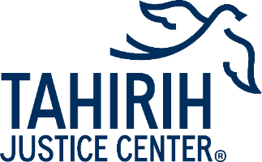

Contents

What is the Light the Way Fund-a-Thon? 3
How to Join 4
Fundraising Tips 4
Sample Language 6
10 Facts About Tahirih 8
GiveGab Instructions 9
FAQs 11

What is the Light the Way
Fund-a-Thon?
The Light the Way Fund-a-thon is a six-week long fundraising campaign where individuals or groups can participate can engage their friends, family, colleagues, and communities to raise critical funds for immigrant survivors of gender-based violence. Individuals or groups can participate for the full duration of the campaign or create a fundraising activity during the campaign period. All funds raised during the fund-a-thon will help light the way for survivors on their journeys to justice.
Never fundraised before? No problem!
Through this fund-a-thon, there are multiple ways you can participate to ensure justice for women, girls, and all immigrant survivors of gender-based violence. It only takes a few minutes to set up your fundraising page and Tahirih staff are here to support you with making your fundraiser a success! Thank you for your passion and commitment to support the journeys of survivors.

How to Join
There are three main ways you can do the Fund-a-Thon:
- Start your own fundraising page: You are the best ambassador for our work! Start your page, engage your network over email or social media, get creative with an event, or by donating proceeds! Start your own fundraiser on our fundraising platform GiveGab. You can spread the word using email and social media templates included below to ask your community for support. You will find instructions on how to create a fundraising page on 9.

- Start a fundraising team: Do you know a group of people who care deeply about our work? You can fundraise with a team in your workplace, community, or with friends! Start your team, set a fundraising goal, and get to work! See page 9 for instructions on how to turn your fundraising page into a team.

- Donating directly: Pull out your credit card, navigate to our fundraising page, and donate! As always, consider making it monthly donation. Bonus points if you forward the link to your friends, family, and BFFs to encourage them to give as well.

Fundraising Tips
Here are a few fundraising tips and ideas to get you started:
- State a clear purpose. When communicating with your network, help them understand why it’s so important to support for immigrant survivors of gender-based violence. You can use the messaging in this toolkit.
- Share why funding justice for women and girls fleeing violence matters to you. Talk about the values or experiences that led you to join Tahirih Justice Center’s Light the Way campaign to support survivors of violence.
- Talk about how Tahirih makes an impact on the lives of survivors. Tahirih provides legal and social services to survivors who are seeking safety in the U.S. For many years, we could only assist 1 out of every 10 survivors who reached out to us, but now we can serve 4 out of 10. Funds raised through this campaign will allow us to provide critical services to survivors who are in urgent need.
- Be sensitive to the fact that some people may not be able to give due to economic conditions or challenges they are facing. Think about other ways they can support you or your fundraising team – like sharing your fundraising page on their social media platforms!

Get Started Today!
- Create your fundraising page or team on GiveGab! Visit tahirih.org/fundathon to register as an individual fundraiser, create a fundraising team, or join a team. Use this platform to track your progress, get fundraising tips, update and thank your donors, and see what your fellow fundraisers (and competitors!) are doing. You will find instructions on how to create a fundraising page on 9.

- Be the first to participate. It’s always a good idea to get your fundraising off to a good start by making the first contribution. This will make others more likely to get involved.

- Look for matching contribution opportunities. Ask your workplace to match donations made by you and your colleagues and reach out to corporate partners and clients for matches. Visit tahirih.org/ways-to-give to learn more about matching gifts.

Spread the Word
- Share on social media. There are buttons on your fundraising page that will allow you to share it on Twitter and Facebook. You can link your fund-a-thon efforts to other relevant events or special days, post about the campaign on social media using our sample posts and images, and reach out to your friends, family, and colleagues to get involved. You can also thank and engage your community on social media.

- Engage through email. Start by emailing your close contacts, as they are the most likely to donate. Try sending personal messages to your inner circle to build up momentum. You can use the fund-a-thon email template you customized to reach all your other contacts.

Engage Your Community
- Unleash the spirit of competition. Leverage personal and professional interest groups (ex. extended family, friends, club members) to fundraise collectively or competitively!
- Host an event. Events are an excellent opportunity to talk about Tahirih and your personal/professional connection to the organization. Host in-person or virtual happy hours, game nights, watch parties, endurance challenges, or more.
- Organize a donate-to-participate day. Speak with your workplace about hosting a day where colleagues can engage in a fun activity (ex. trivia, bingo, photo contest) with a donation to Fund-a-thon. To maximize your efforts, set a suggested donation amount.
- Donating proceeds. Whether you’re a business owner, crafter, or hobbyist, Fund-a-Thon is the perfect opportunity to tie what YOU do to the importance of asylum access. Decide what you’re selling, how you want to fundraise, set a date, and fund justice for immigrant survivors!

Sample Language

Email
Dear [INSERT NAME],
Everyone deserves to live a life free from violence. That’s why I am fundraising in support of the Tahirih Justice Center, a national nonprofit organization that provides critical support to immigrant survivors of domestic abuse, human trafficking, and other forms of gender-based violence on their path towards justice.
Tahirih advocates are working together with their clients to find financial stability, gain access to basic needs, like health care, affordable housing, and educational resources, all while helping them secure the justice they need in the courts.
This cause is very important to me because [INSERT PERSONAL ANECDOTE].
This year, I am raising [INSERT PERSONAL FUNDRAISING GOAL] for Tahirih’s Light the Way Fund-a-thon.
Survivors seeking safety from violence often take a long and arduous journey to find safety and justice. By supporting Tahirih, you can help light their way.
Would you be willing to contribute to my fundraiser? Any gift amount would mean the world to me. To donate, simply click the link to my fundraiser below:
[PROVIDE URL TO FUNDRAISING PAGE].

With gratitude,
[INSERT YOUR NAME]
P.S.
It would also mean a lot if you could share my fundraiser link on social media. This would not only help to bring awareness to my fundraiser and help me reach my goal faster, but it would also be a great way to bring awareness to a wonderful organization!

Facebook and LinkedIn
Everyone deserves to live a life without violence. That’s why I’m joining the Tahirih Justice Center’s Light the Way Fund-a-Thon to raise critical funds to support women, girls, and all immigrant survivors of domestic violence, human trafficking, and other forms of gender-based violence.
Survivors of violence deserve access to safety. Join me to ensure that Tahirih has the resources to continue to fight for the safety and justice for survivors of gender-based violence! You can donate directly on my fundraising page: [INSERT LINK TO FUNDRAISING PAGE].

Instagram
Everyone deserves to live a life without violence. That’s why I’m joining the Tahirih Justice Center’s Light the Way Fund-a-Thon to raise critical funds to support women, girls, and all immigrant survivors of domestic violence, human trafficking, and other forms of gender-based violence.
Survivors of violence deserve access to safety. Join me to ensure that Tahirih has the resources to continue to fight for the safety and justice for survivors of gender-based violence! Click the link in my bio to donate today!
#LightTheWay #TeamTahirih

X/Twitter
I’m fundraising for @tahirihjustice’s Light the Way Fund-a-thon to support immigrant survivors of domestic violence, human trafficking, & other forms of gender-based violence. Join me in ensuring survivors get the support they deserve. [INSERT LINK TO FUNDRAISING PAGE]
#LightTheWay #TeamTahirih

Images
You can download social media graphics at tahirih.org/lighttheway.

10 Facts About Tahirih
- Tahirih has supported more than 34,000 clients and their families since 1997.
- Our free legal services meant clients saved an average of $48,000 in legal fees.
- In 2022, 92 percent of Tahirih cases were closed successfully, as defined by the client and their advocate team.
- The top countries of origin for our clients are Honduras, El Salvador, Afghanistan, Mexico, and Guatemala
- In 2023, our pro bono network included 1,192 attorneys who helped counsel 780 cases.
- Our Afghan Asylum Project has successfully secured asylum for more than 110 Afghans following the crisis in Afghanistan.
- While many of our clients experienced violence in their countries of origin, 57% also experience abuse and exploitation after coming to the U.S.
- In 2023, we engaged more than 10,000 professionals in outreach and training to equip them with an understanding of unique obstacles that immigrant survivors face in the wake of violence, as well as the essential tools needed to help.
- We are a national leader in ending child marriage in America. Our efforts have helped prevent thousands of child marriages across the country.
- We partner with businesses like Airbnb and Uber and organizations like Pro Bono Resource Center of Maryland to connect as many survivors to critical resources as possible.

GiveGab Instructions

1. Create your fundraising page
To start, visit tahirih.org/fundathon and click START FUNDRAISING. It takes just a few minutes to set up! This first step is required for individual fundraising pages and if you wish to later create or join a team.

2. Create a fundraising team
If you are interested in becoming Team Captain and creating a fundraising team through your workplace or community group, after clicking the Start Fundraising button, click the Join or create a fundraising team link on the bottom right side of your fundraising dashboard page, under Your Team.
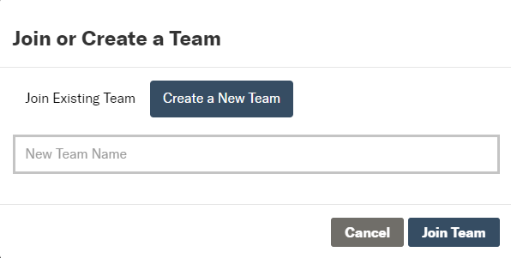
You will be prompted to name your team (we recommend it be the name of your workplace or community group, including the location if you have multiple offices/chapters across the country that will be participating), set a team fundraising goal, and write a team mission statement. You will then be ready to recruit team members to join and start fundraising!
If you choose to fundraise as an individual, or forget to join or create a team, don’t worry! You will still have the option to join or create a team later. Simply revisit your fundraiser dashboard page, by clicking on your name at the top right corner of your page, select Personal Dashboard, and then click on the link to Join or create a fundraising team.

3. Invite others to join your team
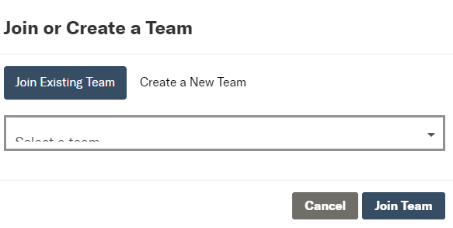
Your friends, family, and colleagues can join forces with you by selecting the Join Existing Team option after they create their own fundraising page (step 1). They can use the search bar to browse the list of teams and select the name of the team they wish to join. To invite specific people to join your team, share your team page URL so they can go directly to your team page to join!

FAQs

Who can participate in the Light the Way Fund-A-thon?
Anyone and everyone are invited to participate! Designed to engage individuals and groups, Bighearted offers the opportunity to donate, mobilize your networks, and recruit others to fundraise. If you’d like to formally involve your company or community group and serve as a Team Captain, contact us at LightTheWay@tahirih.org and set up your own fundraising team!

I’m interested in leading a team! What is the role of the Team Captain?
A Team Captain creates a team for their workplace or community group through Tahirih’s peer-to-peer fundraising platform (tahirih.org/fundathon), sets a team goal, and mobilizes their networks to join. Captains are encouraged to challenge each other to reach their fundraising goals in engaging ways. Note: Captains who enlist the help of others have an easier time reaching their fundraising goal, so it is encouraged to recruit co-captains!

As a Team Captain, what resources are available?
We want the Light the Way Fund-a-Thon to be as easy as possible for our Team Captains, so Tahirih staff will provide a toolkit and other materials, schedule Captain check-ins, send Captain emails, and be available for questions or support throughout the campaign.

Is there a fundraising goal?
Yes! You can find our fundraising goal is shared on our Light the Way page (tahirih.org/fundathon). Team Captains should work with Tahirih staff to determine team goals.

How can I give my network more information?
We encourage fundraisers to share information about Tahirih with friends, family, and colleagues. Sample language can be found in this toolkit. In addition, check out tahirih.org to learn about our mission, the survivors we serve, sign up for e-news, and more.

Who should I contact for questions and support?
Have questions or need advice on how to make your fundraiser a success? Tahirih’s dedicated staff are here to support you. Contact us at LightTheWay@tahirih.org.

